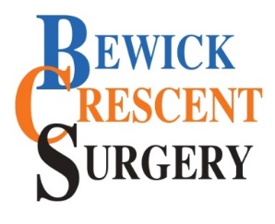 | CONSENT REMOVAL FORM  This form is for remove or update the details of a person who can discuss my medical record.

Patient details

Patient name
Patient's date-of-birth
Address (incl. Postcode)
I am a patient of Bewick Crescent Surgery and I have previously given consent for another person to be able to discuss my medical care pathway and be involved in decision-making. I now wish for their details to be removed from my medical record declining consent for this person to be involved with my care management.

Signature of patient:

Date:

I wish to remove my consent for the person below from discussing my medical care pathway:

Full name
Telephone number
Relationship to patient
Type of access to remove

Care Management (Telephone / F2F) | Yes / No | Online Proxy Access | Yes / No

Bewick Crescent Surgery Only:

Patient Notes Updated On (date):

Initials of staff updating patient's record:

Now add this document to the patient's medical record

